# United Nations Network of Economic Statisticians

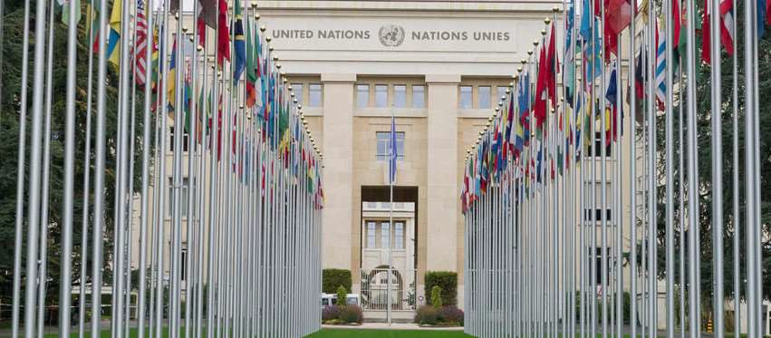

## Purpose

The fifty-second session of the Statistical Commission approved the recommendation of the Friends of the Chair Group on economic statistics to establish a new United Nations Network of Economic Statisticians (Network) to facilitate networking, coordination and communication on new innovations, experiments and best practices for the purpose of making progress on priorities to keep economic statistics relevant, requested that its mandate be clearly defined and provide a transparent and collaborative horizontal coordination mechanism for all existing groups, and recognized the need for the network of economic statisticians to coordinate with other statistical committees and groups, as appropriate, for the purpose of measuring the multidimensional relationships between the economy, environment and society of the 2030 Agenda.

Specifically, the work program of the Network will build on the endorsed recommendations of the Friends of the Chair Group on Economic Statistics for an agile and more responsive system of economic statistics based on four thematic workstreams: (a) networking: collaboration and user consultation; (b) transforming and challenging the system: statistical infrastructure and operations, and data solutions; (c) enabling: institutional arrangements and governance; and (d) experimenting, integrating and documenting: statistical framework and methods.

The task teams of the Network will work agilely in sprints of short duration to complete a series of a set amount of work and deliverables for the thematic workstreams of its work program. The short and intense life cycle of these sprints ensures that momentum is sustained to meet clear objectives.

**Year organized**

2021

## Participants

Senior statisticians from NSOs and international organizations. The NSOs are from the following countries: Australia, Austria, Brazil, Canada, Denmark, Indonesia, Italy, Mexico, Saudi Arabia, and USA. The international organizations include: African Development Bank, Asian Development Bank, Eurostat, Inter-American Development Bank, International Monetary Fund (IMF), Islamic Development Bank, Organisation for Economic Co-operation and Development (OECD), United Nations Economic Commission for Africa, World Bank, and United Nations Secretariat.

### Meetings

#### Organizational sprint

**0** Something (https://unstats.un.org/unsd/trade/events/2019/FOCG/FirstMeetingoftheFOCG.asp)

**0** Something (https://unstats.un.org/unsd/trade/events/2019/Shanghai/default.asp)

#### Inclusive wealth and well-being sprint

**0** Something (https://unstats.un.org/unsd/trade/events/2019/FOCG/FirstMeetingoftheFOCG.asp)

**0** Something (https://unstats.un.org/unsd/trade/events/2019/Shanghai/default.asp)

#### Access to privately-held data sprint

**0** Something (https://unstats.un.org/unsd/trade/events/2019/FOCG/FirstMeetingoftheFOCG.asp)

**0** Something (https://unstats.un.org/unsd/trade/events/2019/Shanghai/default.asp)

### Planned activities:

**0** Terms of Reference for the United Nations Network of Economic Statisticians

### Global user consultation

### Reporting to the United Nations Statistical Commission

The Network will be reporting to the Statistical Commission annually starting from its fifty-third session in 2022.

Active City Groups

**0** Delhi Group (/NetEconStat/citygroups/delhi.cshtml)

**0** London Group (/NetEconStat/citygroups/london.cshtml)

**0** Oslo Group (/NetEconStat/citygroups/oslo.cshtml)

**0** Ottawa Group (/NetEconStat/citygroups/ottawa.cshtml)

**0** Praia Group (/NetEconStat/citygroups/praia.cshtml)

**0** Titchfield City Group (/NetEconStat/citygroups/Titchfield.cshtml)

**0** Voorburg Group (/NetEconStat/citygroups/voorburg.cshtml)

**0** Washington Group (/NetEconStat/citygroups/washington.cshtml)

**0** Wiesbaden Group (/NetEconStat/citygroups/wiesbaden/)

# About

The United Nations Statistics Division is committed to the advancement of the global statistical system. We compile and disseminate global statistical information, develop standards and norms for statistical activities, and support countries' efforts to strengthen their national statistical systems. We facilitate the coordination of international statistical activities and support the functioning of the United Nations Statistical Commission as the apex entity of the global statistical system.

# UNSD Work Programme

**f)** Statistical Classifications (<http://unstats.un.org/unsd/class/default.asp)>

**f)** Big data for official statistics (<http://unstats.un.org/bigdata/)>

**f)** Development indicators (<http://unstats.un.org/sdgs/)>

**f)** Geospatial Information (<http://unstats.un.org/unsd/geoinfo/)>

**f)** Demographic and Social Statistics (<http://unstats.un.org/unsd/demographic/default.htm)>

**f)** Gender Statistics (<http://unstats.un.org/unsd/gender/default.html)>

**f)** Industry Statistics (<http://unstats.un.org/unsd/industry/default.asp)>

**f)** Trade Statistics (<http://unstats.un.org/unsd/trade/default.htm)>

##### **f)** Tourism Statistics (https://unstats.un.org/unsd/tourism/)

**f)** National Accounts (<http://unstats.un.org/unsd/nationalaccount/default.asp)>

**f)** Energy Statistics (<http://unstats.un.org/unsd/energy/default.htm)>

**f)** Environment Statistics (<http://unstats.un.org/unsd/environment/default.htm)>

**f)** Environmental-Economic Accounting (<http://unstats.un.org/unsd/envaccounting/default.asp)>

# Contact Us

Statistics Division United Nations

New York, NY 10017 United States of America

**m** [statistics@un.org](mailto:statistics@un.org) (mailto:statistics@un.org)

\. Fax +1 (212) 963-9851

# Stay Connected

© 2021 United Nations (<http://www.un.org/en/aboutun/copyright/)> • Terms of Use (<http://www.un.org/en/aboutun/terms/)> • Privacy Notice (<http://www.un.org/en/aboutun/privacy/)> • Fraud Alert (<http://www.un.org/en/aboutun/fraudalert/)>